Sample TEST (Units 7 and 8)
I) Slušaj i upiši brojeve.
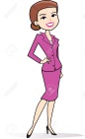 _____ 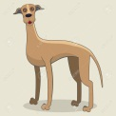 ________ 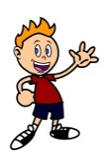______ 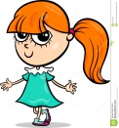_______ 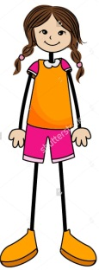_______
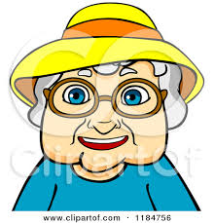 _______ 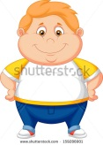 _________ 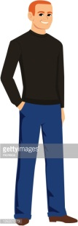__________ 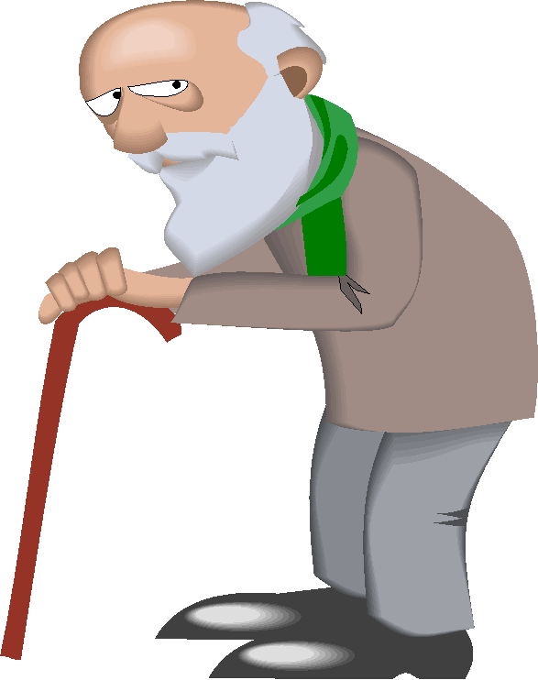___________ 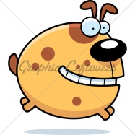________
II) Opiši ljude koristeći date reči.

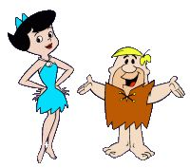
He’s short and thin. He’s and fat. blond hair. hair.
She’s got She’s tall short black got short
____________________________________________________
_____________________________________________________

III) Odgovori na pitanja.
1. Whose book is this? (Polly) ________________________
2. Whose jumper is this? (Jack) _______________________
3. Whose shoe is this? (Greg) _________________________
4. Whose rubber is this? (Polly) _______________________
5. Whose hat is this? (Dad) __________________________

IV) Slušaj i oboji.
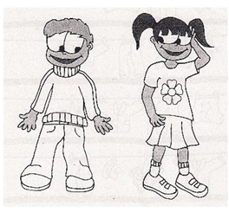

V) Pogledaj slike i dopuni rečenice.
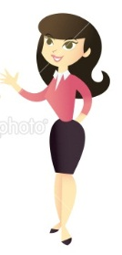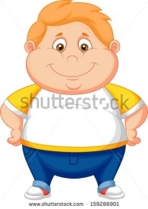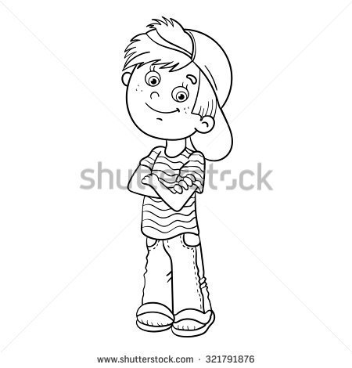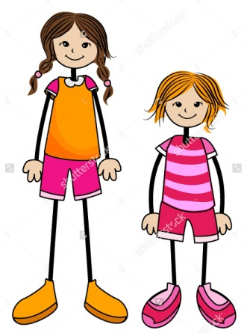

1. The fat boy is wearing a white _______________________.
2. The tall girl has got _______________________ dark hair.
3. The young woman is _______________________ a black _______________________ and black shoes.
4. The old _______________________ is wearing glasses.
5. The thin _______________________ is wearing a ____________________ on his head.
6. The old woman has got short _______________________hair.
7. The young woman isn’t fat. She’s very _______________________.
8. The _______________________ girl has got short hair.

