UNITS 5 & 6 TEST/ HAPPY STREET 1 SAMPLE TEST
I) Listen and write the numbers. _____/10

_________ _________ _________ _________ _________ _________ _________ _________ _________ _________

II) Listen and write the numbers. _____/8

_________ _________ _________ _________
_________________ _________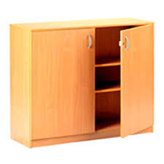_________

III) Listen and draw. _____/6
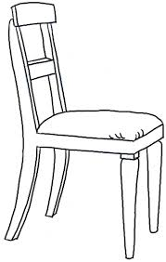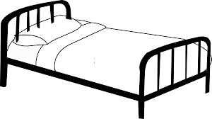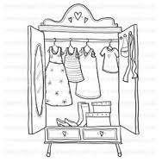

IV) Write the sentences. Use I’VE GOT / I HAVEN’T GOT. _____/3

___________________________________________
___________________________________________
___________________________________________

V) Read and match. _____/5
1) Have you got a bike? It’s red.
2) Where’s my hamster? There’s a bunk bed in my bedroom.
3) Is he in the cage? Yes, I have.
4) What’s in your bedroom? No, he isn’t.
5) What colour is Greg’s bed? In the kitchen.

VI) Look, read and answer. _____/5

1. Where’s the doll? It’s_________________________________________________________.
2. Where’s the dinosaur? ____________________________________________________________.
3. Where’s the robot? ____________________________________________________________.
4. Where’s the ruler? ____________________________________________________________.
5. Where’s the boat? ____________________________________________________________.

