Unit 2 Project 2 SAMPLE Test

I) Label the pictures.
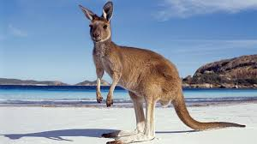 1._____________ 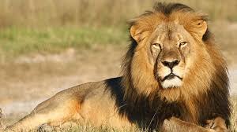2. _____________ 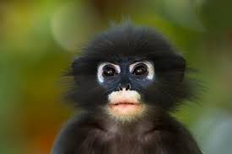 3. ____________
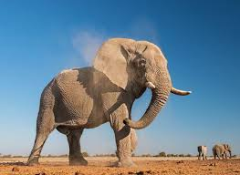 4. _______________ 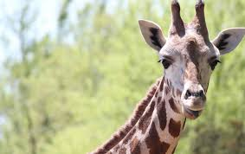 5. _____________

II) Read, choose and circle.
- I wash/ washes/ washing up every day.
- Jack making/ is making/ makes the bed at the moment.
- Are / Does/ Do you always feed the chickens?
- My parents are watching/ watching/ watch TV now.
- Ralph doesn’t/ isn’t/ don’t taking a photo.
- Is/ Does/ Are your friend drinking juice now?
III) Put the words in brackets in the correct form: Present Simple or Present Continuous Tense.
- They _______________________ (have) lunch at the moment.
- Dad usually _______________________ (take) out the rubbish.
- _______________________ (you, sleep) now?
- I_______________________ (not sit) in the car at the moment.
- Monika _______________________ (not go) to the cinema every weekend.
- _______________________ (you, tidy) your room every day?
- I never _______________________ (do) my homework in the evening.
- _______________________(she, get) on the bus now?
IV) Fill in with the correct subject or object pronoun.
- I like Molly very much. ___________ is my best friend.
- You must clean this cage. ___________ is very dirty.
- I love monkeys. I like to watch ___________on TV.
- Jack is my brother. I go to school with ___________.
- My dad loves birds. ___________ always reads books about them.

V) Read the text and circle T if the sentences are true or F if they are false.

Ryan Brown is ten years old. He lives in a big house in London with his father, Mr Brown, his mother Laura, and his little sister, Claire.
His father is a vet and his mother is a teacher. Claire is a baby.
Every morning they get up early. At 7.20 Ryan has a shower. Then he goes to the dining room where he has breakfast.
Bryan’s mum and dad go to work by car. His dad drives it. Ryan walks to school with his best friend Jason. Claire stays at home with the baby-sitter.
At noon Ryan has lunch in the school canteen with his friends.
Ryan goes back home at 3.30 p.m. He does his homework and his mum sometimes helps him. Mr Brown usually reads a book before dinner. They have dinner at 7.30 p.m. After dinner, Bryan helps his mum in the kitchen. She washes up and he takes out the rubbish. After dinner, they watch their favourite TV programme and then they go to bed.
- Ryan lives in a village. T F
- Claire doesn’t go to school. T F
- Mr Brown works with animals. T F
- Ryan takes the bus to school. T F
- Ryan has lunch at 12 o’clock. T F
- Ryan washes up after dinner. T F
VI) Fill in:
magazine duck hole bear king must listen cow
climbing mouth

1. A ___________is a dangerous animal.
2. Look! The monkey is ____________ a tree.
3. Do you ___________ to popular music?
4. Mut’s got a bone in his ___________.
5. Are you reading a _____________?
6. A __________ gives us milk.
7. The cage is dirty. You ___________ clean it.
8. The mouse is hiding in his __________.
9. A _________ can swim.
10. Chicken Licken goes to London to see the _________.

