Test (Units 3 & 4) group 1

Name: _________________________________________________________________

1. Odgovori koristeći Yes, it is. ili No, it isn’t.

1. 2. 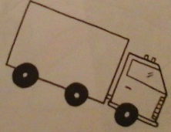 3. 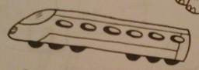 4. 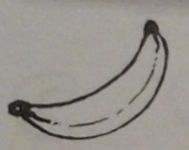 5. 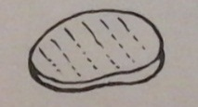
Is it a pear? Is it a car ? Is it a train? Is it a box? Is it a pen?
___________ ___________ _____________ __________ ____________

2. Napiši reči za date slike.

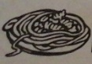 1. _________ 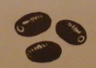 2. _________ 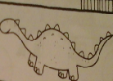 3. ___________ 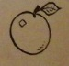 4._________ 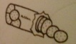 5. ___________

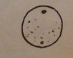 6. _________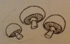7. __________ 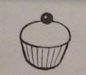8. ___________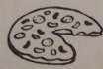9. ___________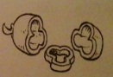10. __________

3. Napiši A ili AN:

______banana ______ice cream ______ pen ______cake ______apple

4. Popuni tabelu datim rečima:

seven pasta black ten chocolate yellow
robot five doll blue
Toys | Food | Colours | Numbers

5. Koristeći date reči napiši rečenice koje počinju sa I like ili I don’t like:

bananas robots steak dolls chocolate ice cream cars lorries pears trains

1.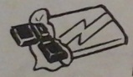 _______________________________________
2. 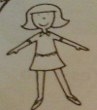 _______________________________________
3. 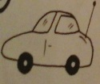 ______________________________________
4. 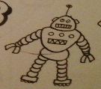 _______________________________________
5. 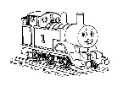 _______________________________________
6. 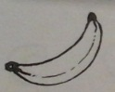 _______________________________________
7. 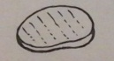 _______________________________________
8. _______________________________________
9. 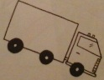 _______________________________________
10. _______________________________________

6. Popuni rečenice datim rečima:

Anything great know please Can snack plastic thank favourite Do

1. A: What’s this? B: I don’t _________________________.
2. This is my robot. It’s made from _________________________.
3. This car is my _________________________ toy.
4. _________________________ I have six oranges, please?
5. No, _________________________you. I don’t like chocolate.
6. Yes, _________________________! I like apples.
7. _________________________ else?
8. _________________________ you like olives?
9. I like dogs- dogs are _________________________.
10. It’s time for a _________________________.

