SAMPLE TEST – PROJECT 1 (UNIT 5)

I) Write There is or There are. ____/5
1._______ a bank here.
2._______ two hotels in this town.
3. _______ a swimming pool in the sports centre.
4. _______ cafes in the city centre.
5. _______ a lot of shops in the shopping centre.

II) Use CAN or CAN’T and these verbs to make sentences.
dance write play ride draw
1. You /X________________________________________.
2. You/ √ _____________________________________a bike.
3. We/ √_________________________________________.
4. Jack/ X ________________________________ the violin.
5. Sarah/ X ______________________________________.

III) Make questions. Use CAN, THERE IS or THERE ARE: _____/7
1. John / swim
________________________________________
2. a mirror/ on the wall ________________________________________
3. we / go out
________________________________________
4. a cat / in front of your house ___________________________________
5. two post offices /in your town ________________________________________
6. your little sister / speak Italian
______________________________________
7. ten pencils / in my bag ________________________________________

IV) Write short answers: _____/8
1. Can dogs sing? _______________________
2. Is there an iPad on that table? _______________________
3. Can you write your name? √ _______________________
4. Are there fifteen desks in your classroom? √ _______________________
5. Can your sister draw good pictures? X _______________________
6. Have you got a sister? X _______________________
7. Can Tom and Peter play golf? √ _______________________
8. Are you hungry? X _______________________

V) Look at the picture and label the places in the town.
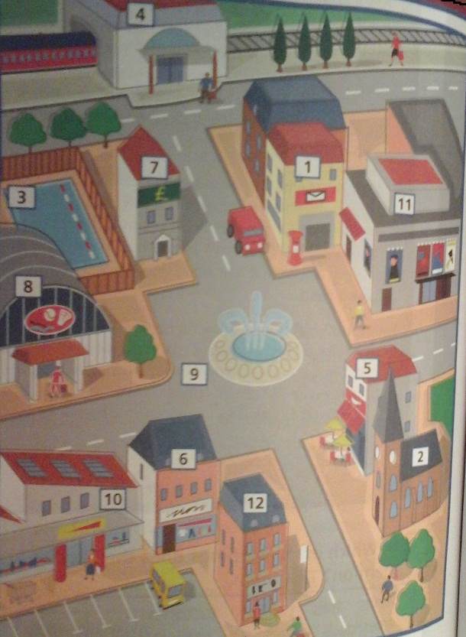
1______________ 2 ______________ 3 ______________ 4______________ 5____________ 6. ______________

VII) Look at the picture. Complete the sentences with these prepositions:
IN, ON, UNDER, BETWEEN, BEHIND, IN FRONT OF, NEXT TO
_____/5
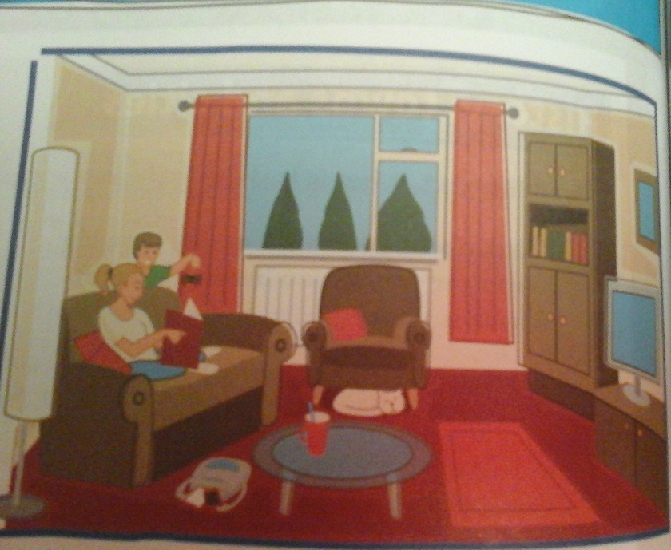
1. The cat is ____________________ the armchair.
2. The bag is ___________________ the sofa and the table.
3. The television ___________________ the cupboard.
4. The boy is ____________________ the sofa.
5. The table is ___________________ the rug.

VIII) Fill in:
UNIT 5, LESSONS: A, B, C, D _____/10

computer next speak stairs bedroom blue bed opposite downstairs three

1. Where’s Sally’s house? It’s_______________ the park.
2. Where’s the dining room? It’s _______________.
3. Where’s the toilet? It’s under the _________________.
4. How many bedrooms are there? There are _______________.
5. What colour are the curtains in your room? They’re __________.
6. What’s on Sally’s desk? Her _______________.
7. Where does she do her homework? In her _______________.
8. Where does the cat sleep? Under the _______________ .
9. Can you _______________ English?
10. The dining room is _______________ to the kitchen.

